BID FORM
Dated: ____________________________
To,
The Registrar
NIT Mizoram
Chaltlang, Aizawl, Mizoram - 796012

Tender No: NITMZ/RP-16-1/2021/3289 Date:18th August, 2022
Madam,
- Having read the terms and conditions of the above mentioned tender and equipments to be provided, we undersigned, offer to provide the equipments (mentioned in Annexure-V) in conformity with the conditions of contract and specifications for the sum shown in the schedule of prices attached herewith in separate sealed cover and made part of this Bid.
- If our Bid is accepted, we will obtain the bank guarantees from a Scheduled Bank for a sum as mentioned in this tender document for due performance of the Contract.
- We agree to abide by this Bid for a period of 90 days from the date fixed for Bid opening and it shall remain binding upon us and may be accepted at any time before the expiry of that period.
- Bid submitted by us are properly sealed and prepared so as to prevent any subsequent alteration and/ or replacement.
- We understand that you are not bound to accept the lowest or any bid, you may receive.
- NIT Mizoram reserves the right to cancel the tender without assigning any reason.
- NIT Mizoram reserves the right to reject any or all tenders without assigning any reasons whatsoever.

Signature
Full Name
Name of Firm/Company/Agency
Seal

ANNEXURE -I

- COMPLIANCE CERTIFICATE FOR NIT TERMS
(To be enclosed in the Technical bid)

Sl. No. | NIT Terms and Conditions | Yes/No
01 | Rate quoted as per instruction
02 | AMC rate after warranty provided
03 | Validity of quoted rate for 90 days agreed
04 | EMD submitted (appropriate certificate enclosed)
05 | PBG term agreed
06 | Payment term agreed
07 | Delivery terms agreed
08 | Warranty period agreed
09 | Literature: Printed Literature provided
10 | Dealership / distributorship certificate (in case of dealers/agents) provided
11 | Sales Service: address of after Sales Service centre in India (for imported goods)/ in the region provided
12 | Applicable law terms agreed

Signature with Seal:……………….
Vendor: M/s………………………

- COMPLIANCE CERTIFICATE FOR SPECIFICATIONS
(One for each item must to be enclosed in the Technical bid)

Item Sl. No.:
Specifications as per Annexure-IV | Quoted Item Specs.* | Complied  (Yes/No)

Signature with Seal:…..………….
Vendor: M/s………………………
* Vendor must quote the parameter specification of the quoted product in this column and not just copy the specification from the tender call document. Failure to do so will lead to rejection of the tender.

ANNEXURE –II

PERFORMANCE BANK GUARANTEE

To:

The Registrar
National Institute of Technology
Aizawl-796012, Mizoram

WHEREAS..................................................................................................................... (Name of Supplier)
hereinafter called "the Supplier" has undertaken, in pursuance of Contract No................. dated,......... 20... to supply...................... ................................................. (Description of Goods and Services) hereinafter called "the order".

AND WHEREAS it has been stipulated by you in the said order that the Supplier shall furnish you with a Bank Guarantee by a recognized bank for the sum specified therein as security for compliance with the Supplier's performance obligations in accordance with the order.

AND WHEREAS we have agreed to give the Supplier a Guarantee:
THEREFORE WE hereby affirm that we are Guarantors and responsible to you, on behalf of the Supplier, up to a total of........................................................................... (Amount of the Guarantee in Words and Figures) and we undertake to pay you, upon your first written demand declaring the Supplier to be in default under the order and without cavil or argument, any sum or sums within the limit of ................................ (Amount of Guarantee) as aforesaid, without your needing to prove or to show grounds or reasons for your demand or the sum specified therein.

This guarantee is valid until the ........day of...................20......

Signature and Seal of Guarantors
................................
................................
................................
Date......................20....
Address………….........
......................................
......................................
All correspondence with reference to this guarantee shall be made at the following address: National Institute of Technology Mizoram

ANNEXURE -III

MANUFACTURERS'/ DISTRIBUTOR’S AUTHORIZATION FORM

No. Dated __________

The Registrar
National Institute of Technology
Aizawl-796012, Mizoram

Dear Madam:
We………………………………………………………………………. who are established and reputable
Manufacturers/distributors of ……………………………………………………………………having factories/office at----------------------------------------------------------------------------------------------------------
--------------------------------------------------------------------------------------------------------------------------------------------------------------------------------------------------------(address of factory/office) do hereby certify that…………………………………………………………………………………………………………………………………………………………………………………………………………………………………………(Name of the Authorized Dealer)is our authorized dealer to quote against your tender enquiry no …………………………………………………………………………………………………………..., Last Date of Submission is:

Yours faithfully,
(Name)
(Name of Manufacturer/Distributor)

ANNEXURE-IV

CONTRACT FORM

Contract No. _____________________________ Date: _______________
THIS CONTRACT AGREEMENT is made
The[insert:number] day of [insert:month], [insert:year].
BETWEEN
- National Institute of Technology, Mizoram, Chaltlang, Aizawl represented by _______________ [insert complete name and address] of Purchaser (hereinafter called “the Purchaser”), and
- [ insert name of Supplier ], a corporation incorporated under the laws of [ country of Supplier ] and having its principal place of business at [ insert: address of Supplier ] (hereinafter called “the Supplier”)
WHEREAS the Purchaser invited bids for certain Goods and ancillary services, viz.,[insert brief description of Goods and Services] and has accepted a Bid by the Supplierfor the supply of those Goods and Services in the sum of [insert Contract Price in wordsand figures, expressed in the Contract currency] (hereinafter called “the ContractPrice”).
NOW THIS AGREEMENT WITNESSETH AS FOLLOWS:
- In this Agreement words and expressions shall have the same meanings as are respectively assigned to them in the Conditions of Contract referred to.
- The following documents shall constitute the Contract between the Purchaser and the Supplier, and each shall be read and construed as an integral part of the Contract:
- This Contract Agreement
- General Conditions of Contract
- Technical Requirements (including Schedule of Requirements and Technical Specifications)
- The Supplier’s Bid and original Price Schedules
- The Purchaser’s Notification of Award
- [Add here any other document(s)]
- This Contract shall prevail over all other Contract documents. In the event of any discrepancy or inconsistency within the Contract documents, then the documents shall prevail in the order listed above.
- In consideration of the payments to be made by the Purchaser to the Supplier as hereinafter mentioned, the Supplier hereby covenants with the Purchaser to provide the Goods and Services and to remedy defects therein in conformity in all respects with the provisions of the Contract.
- The Purchaser hereby covenants to pay the Supplier in consideration of the provision of the Goods and Services and the remedying of defects therein, the Contract Price or such other sum as may become payable under the provisions of the Contract at the times and in the manner prescribed by the Contract.
IN WITNESS whereof the parties hereto have caused this Agreement to be executed in accordance with the laws of Union of India on the day, month and year indicated above.
For and on behalf of the National Institute of Technology, Mizoram
Signed: [insert signature] in the capacity of [insert title or other appropriate designation] in the presence of [insert identification of official witness]
Signed: [insert signature] in the capacity of [insert title or other appropriate designation] in the presence of [insert identification of official witness]
For and on behalf of the Supplier
Signed: [insert signature of authorized representative(s) of the Supplier] in the capacity of [insert title or other appropriate designation] in the presence of [insert identification of official witness]

ANNEXURE-V

LIST OF EQUIPMENTS & SPECIFICATION FOR DRYING LABORATORY

Sl No. | Name of Equipment | Technical Specification | Qnty.
1. | Data Acquisition System with 32 Nos. Voltage Channels | System should be available with 3 slots in Mainframe for multiplexer.  Built-in 6. digit DMM should be available.  System should be capable of Measure and converts different input signals:  a. Temperature with thermocouples  b. RTDs and thermistors  c. DC/AC volts  d. 2 and 4 wire resistance  e. Frequency and period  f. DC/AC current and capacitance  LAN and USB must be available for easy connectivity to PC.  USB flash drive support to copy/log data in standalone applications required  Built-in signal conditioning must be available  No of Channel : minimum 32  Measurement Speed : ≥80 Ch/Sec  Max Volts : ≥300V  Max Current : ≥1A  System Must be supplied with Test Automation software over LAN | 1
2. | Water Activity Meter | Accuracy at 23 ±5 °C :± 0.009 aw / 0.8 %RH / ±0.1 K or better  Probe type : Measurement probe with USB interface  Range of application : -40-85 °C (-40-185 °F) / 0-100 %RH  Long-term stability : <1 %rh / year or better  Filter type : Wire mesh filter with 20-25 μm pore size  Response time :<25 sec.  Psychrometric calculations : Dew or frost point  Measurement interval : 1s or better  Communication interfaces : USB  IP protection rating : IP20  Material : Stainless steel, aluminum  Software: Measurement ad Data analysis software to be provided. | 1
3. | Thermocouples | K Type Thermocouple, -20 to 500 °C, Chromel | 20
4. | Pyranometer | Solar irrigation measuring range: 1 W/m2 to 1200 W/m2  Energetic exposure measuring range : 1 Wh/m2 to 450 kWh/m2  Frequency of the measure. : 1/ s  Accuracy : 5% of measurement or better  Calculation frequency (W/m2) : 1 / min  Storage capacity : 30 days  Data download Speed : 1000 values/second  Operating temperature : -10°C to +40°C  Spectral response : 450 to 1000 nm  Nominal sensitivity : 100mv for 1000W/m2  Coefficient in temperature : +0,1% /°C  Effective area : 1 cm2  Mode : Photovoltaic  Material : Polycristallin | 1
5. | All In One Desktop/ printer/UPS | Desktop  Processor Brand Intel  Processor Type Core i5  Processor Speed 1.6 GHz  RAM Size 8 GB  Memory Technology DDR4  Computer Memory Type DDR DRAM  Hard Drive Size 1 TB  Audio Details Speakers  Graphics Card Description Integrated  Connectivity Type Wi-Fi  Wireless Type 802.11n  Hardware Platform Windows  Operating System Windows 10 Home  Display 23.8 inch  Keyboard & Mouse Standard  Printer  Printer Type : LaserJet;  Functionality : Multi-Function (Print, Scan, Copy)  Scanner type : Flatbed  Printer Output : Black & White only  Connectivity : USB  Dual digit numeric LED display  Pages per minute : 18 pages  Page size supported : A4, A5, B5, C5, C6, DL, Postcard ;  Duplex Print : Manual  Print resolution : Up to 600 x 600 DPI (1200 DPI effective)  Scan speed ( : Up to 6 ppm (b&w), up to 3 ppm (color),  600VA UPS For Desktop  Input Voltage • 230 V/ 1 Phase  Input Plug Type • PLUG 3 PIN  Output Voltage • 230 V  Output Frequency • 50Hz  Output Power Wattage • 360 W  Efficiency • >65% %  Output Waveform • Quasi Sinewave  Transfer Time • 5 ms  Number of Outlet Plugs • 3  Surge Protection • YES  Display Indicator Functions • MAINS/BATTERY/FAULT INDICATOR  Audible Indicator Functions • LOW BATT AND FAULT | 1
6. | Moisture Tester | Max Capacity50g  Min Capacity0.03g  Minimum Readability 0.001g  Repeatability 0.18%  Drying Heater Straight type halogen heater  Power 350 -400W  Temperature range 50 – 180 °C (1°C increments)  Display LCD with backlight  Measurement modes Standard/ Rapid drying/ Slow drying/ Step drying  Timer setting 1-110 minutes or continuous  Interface USB | 1
7. | Digital Weight Balance | Max Capacity : 220 g  Readability : 0.1 mg [0.0001g]  Linearity : ± 0.2 mg  Tare Range : Full Capacity [-220 g]  Repeatability : ± 0.1 mg  Pan Size :100 mm Dia.  Minimum weight : 14 mg  Minimum weight (USP): 140 mg  Draft Shield : Manual Draft Shield  Weighing Unit :G, kg, ct, lb, oz, ozt, tlh, tls, tlt, Gn, dwt, mg, /lb, tlc, mom, k tol, bat, and MS.  Weighing, Parts Counting, Check weighing, Percent setup, Formulation,  Dosing, , Peak hold, Statistics, Animal Weighing, Density, under hook  weighing, Autotest, totalizing , alibi memory, Ambient Conditions  Measurement  Calibration : Internal [automatic]  Stabilization Time : 2 Seconds  Inter face : 2 × RS 232, USB-A, USB-B | 1
8. | Mixed Mode solar dryer Integrated with Biomass Furnace (Taylor Made items) | Solar Air Heater  MS fabricated with outer Gl sheet  Dimension: 150 cmx100 cmx12 cm  Surface Area: 1.5 m2  Glaze: Polycarbonate sheet of 2.5-5 mm thick  Absorber: 0.8-1 mm thick aluminium sheet coated with high absorbing powder coating  Mounting angle: 20-260 (adjustable)  lnsulation with glass wool  Biomass Furnace  Fuel: Wood (preferably)  Height: 250-350 cm  Duct size: 15mx1Scm  Heat Exchanger: Plate type, 12 plates of 40 cmx40 cm, 3.6 cm dia,65-70 cm Length / 36  Ms tubes  Combustion Chamber lnsulation: Kiln bricks  Expected outlet air temperature is 80-85"C  Dryinq Chamber  Material: MS fabricated Gl coated with top transparent poly carbonate, SS wire mesh  Drying chamber type: h"qgizdntal flow direction with a plenum  Dimension: 200cmx 1 50cmx 1 00cm  No of Tray: 4-6 (Wire mesh type), trays are removable type  Tray dimension: 1 50cmx1 00cm  Holding capacity: 60 kg approx. (each tray should be able to support at leasts kg moist agro-products)  PV Panels  Output: 320 Wp, 24 V  Type; Monocrystalline  Nominal Maximum Power (Pm) in Watts: 320  Powertolerance: 0/+5W  Open Circuit Voltage (Vo") in Volts: 45.30  Short Circuit Current (l'") in Amps: 9.42  Voltage at Maximum Power (V,np) in Volts: 36.80  Current at Maximum Power (lmp) in Amps: 8.70  Maximum System Voltage in Volts: 1000  Module Efficiency (%): 16.50  Maximum Series Fuse Rating (A): 15  *Under Standard Test Conditions (STC) of 1000 Wm2 irradiance  Battery,Charge Controller, Inverter  Battery. 150 Ah or higher capacity (each); compatible with 24V solar PV panels as input.  Charge controller: MPPT lype24 v DC 60 Amp  Inverter: DC to AC convertible, with MPPT charge controller Off grid Standalone, mode.  Biomass Preheater  Material: steel body, glass top  Dimensions’ 60cmx 1 60cmx 1 60cm  Capacity: 200-400 kg per batch  Insulation: polyurethane/glass wool 3 cm thick  Biomass and flue gas in separate channel  Top cover: Transparent sheet  Blower & Fans  1hp (centrifugal) blower and 3 fans of appropriate capacity 170 CFIVI 9-inch size operated by battery with provisions for AC input. One other fans of smaller capacity all driventhrough the same battery.  65 WATT 9" fans with 170 CFMI air flow 230v ac fans  Sensors for Temperature, Pressure,Humidity and velocity  Temperature measurement including Thermocouple, Signal conditioner, ADC, software (15-20)  Measurement of humidity including Thermocouple, Signal conditioner, ADC, Software (3-4)  Pressure sensor and pressure data logger  Velocity sensor and velocity datalogger  Voltage and Current (4-5)  Control and Monitoring Systems  All he measured parameters from the sensor are connected to the computer (Intel i5, 1 TBHDD, 8 GB RAM or equivalent) with data acquisition interface | 1

ANNEXURE-VI
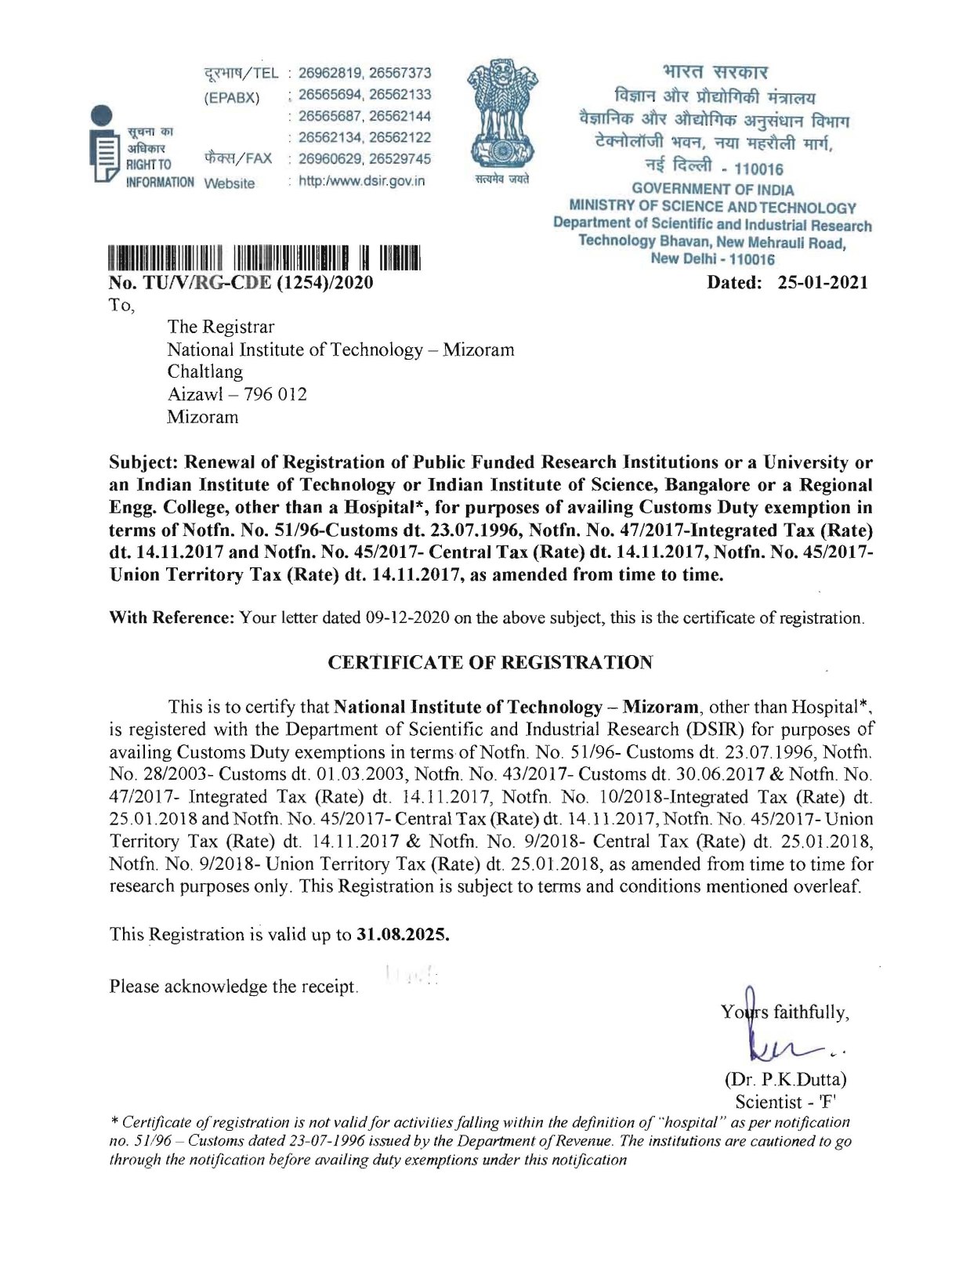

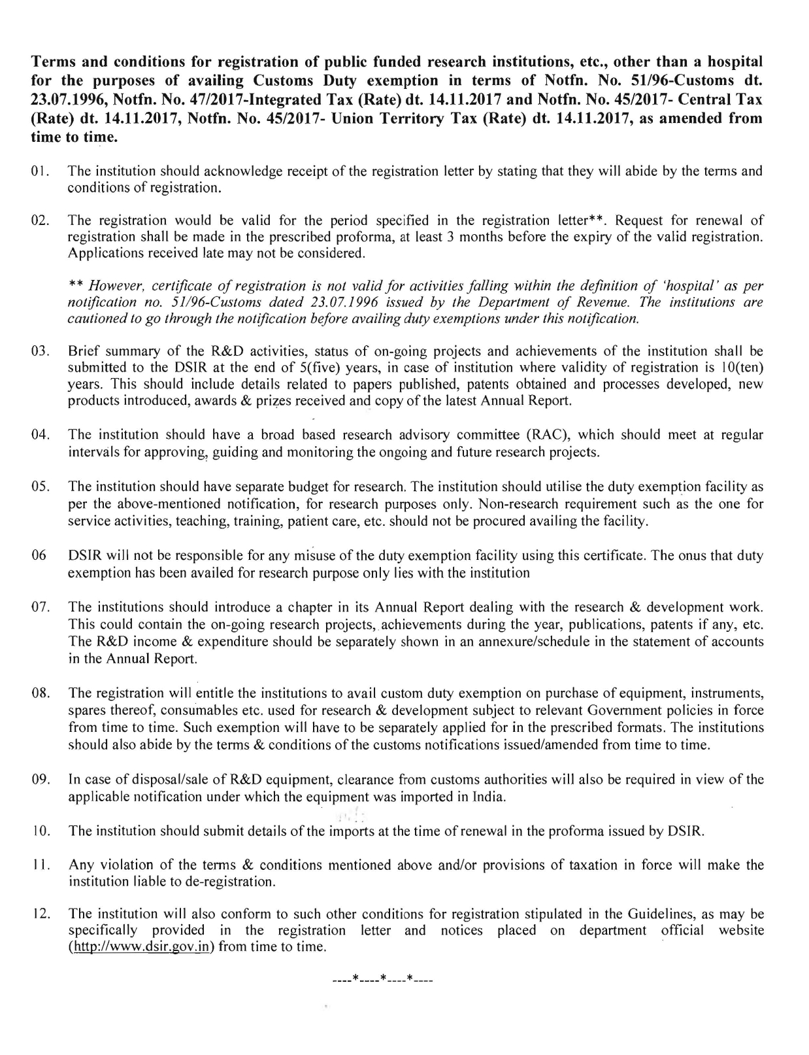

ANNEXURE-VII

PROFORMA for FINANCIAL BID
1. Rate for each item shall be filled in Column 3. Leaving blank for any item is NOT permitted in the Financial Bid Form, in such cases the Bid will be treated as non responsive and will be summarily rejected.
2. Conditional Bid shall not be considered and will be rejected outright.
LIST OF EQUIPMENTS & SPECIFICATION FOR DRYING LABORATORY

Sl No. | Name of Equipment | Qnty. | Basic Rate  (INR in Figure) | Total Amount (In Word)
1 | 2 | 3 | 4 | 5
1. | Data Acquisition System with 32 Nos. Voltage Channels | 1
2. | Water Activity Meter | 1
3. | Thermocouples | 20
4. | Pyranometer | 1
5. | All In One Desktop/ printer/UPS | 1
6. | Moisture Tester | 1
7. | Digital Weight Balance | 1
8. | Mixed Mode solar dryer Integrated with Biomass Furnace (Taylor Made items) | 1

I/We have read and understand the tender for supply & installation of equipment & mixed mode solar dryer integrated with biomass furnace in Mechanical Engineering Department at NIT Mizoram vide No. NITMZ/RP-16-1/2021/2613 Dated 13.05.2022 and other documents issued by you we hereby quote the Rates (inclusive of all taxes & duties) except Goods & Services Tax (GST) as above. GST Rates applicable shall be quoted separately.

Date: [Signature]
Place: Name of the Bidder
Seal of the Bidder

